Stage Directions and Helpful Tips
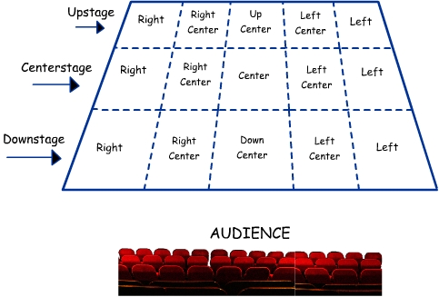Blocking phrases-
Cross- to move across the stage
Double cross- when two people move across the stage in opposite directions
Cheat- angling your body so your voice goes out into the house, not upstage
Shorthand for blocking notes-
DS- downstage
CS- center stage
US- upstage
L- left
R- right
C- center
X- Cross
Acting Tips-
Upstaging happens when your stage partner needs to turn upstage to talk to you, thus making it hard for the audience to hear those lines. Always be aware of the angle of your body, if you feel you are looking too far upstage to deliver your lines let us know and we can change the blocking.
ALWAYS cheat toward the audience, this way all your lines can be heard. We want to see your lovely faces!
Be aware of sight lines- if you can see the audience, they can see you. This is especially important while you are waiting backstage for your cue.

